**CROWDFUNDING APP FOR EDUCATION**

**A MINI PROJECT REPORT (15CS72C)**

***Submitted by***

**JESU PANDIAN J KARTHICK B**

***In partial fulfillment for the award of the degree of***

***BACHELOR OF ENGINEERING***

***in***

***COMPUTER SCIENCE AND ENGINEERING***



**NATIONAL ENGINEERING COLLEGE**

# (An Autonomous Institution, Affiliated to Anna University – Chennai)

**K.R. NAGAR, KOVILPATTI – 628 503 June 2022**

**BONAFIDE CERTIFICATE**

Certified that this mini project report “**DIGITAL BULLETIN BOARD**” is the bonafide work of **DONALD P (REGISTER NO: 1812111), SAKTHIVELRAJAN K (REGISTER NO: 1812114)** who carried out the project work under my supervision.

|  |  |
| --- | --- |
| **SIGNATURE**  **Dr.V.GOMATHI M.Tech., Ph.D.,**  **Head of the Department** Professor and Head Department of CSE,  National Engineering College (An Autonomous Institution)  K.R.Nagar, Kovilpatti: 628503. | **SIGNATURE**  **Mr.S.RAJESH KUMAR ME.,**  **Guide/Supervisor**  Assistant Professor Department of CSE,  National Engineering College (An Autonomous Institution)  K.R.Nagar, Kovilpatti: 628503. |
|  |  |

Submitted to the **MINI PROJECT (15CS72C)** Viva-Voce Examination held at National Engineering College on …………………………

# Internal Examiner External Examiner

**ACKNOWLEDGEMENT**

First and foremost, we would like to thank God Almighty for showering his blessings throughout our life. He has been the tower of our strength in each step of our work. We take the privilege to express hearty thanks to our parents for their valuable support and effort to complete the project work.

We would like to express our deep sense of gratitude and respectful regards to our director **Dr. S. Shanmugavel B.Sc., D.M.I.T., Ph.D.,** for giving an opportunity to do this work.

We have great pleasure in acknowledging our Principal **Dr. K. Kalidasa Murugavel, M.E., Ph.D.,** for extending his full support to undergo this work.

We express our profound thanks to our beloved Head of the Department **Dr. V. Gomathi., M.Tech., Ph.D.,** for extending her full support and providing various facilities during the project work.

We would like to thank our project guide **Mr S.Rajesh Kumar M.E.,** Assistant Professor, Department of Computer Science and Engineering, whose valuable guidance, technical support and suggestions helped us for doing the project work.

We express our gratitude to our project coordinator **Dr. P. Kalaiselvi M.E., Ph.D.,** Assistant Professor (Sr. Grade) Department of Computer Science and Engineering for his valuable guidance at each and every stage of the project.

We extend our hearty thanks to our tutors and class in-charges for their valuable guidance. We are grateful to all the staff members and our dear friends for their valuable suggestion and co-operation for this project work.

# ABSTRACT

The crowd fund raising mainly focuses on providing funding for those who has skills but in need of money to achieve something, it includes highly paid certifications and higher studies this system reduces all paper work was need to be done and also promotes legitimacy by making this as a community. Someone can get fund by providing the details of eligibility criteria they have to do that, one who want to enroll in this forum need to create a account in the forum. Also, there will be a module which enhances donation to the forum from alumni’s and government. All request will be public in forum with an upvote option so a person who is highly skilled and can efficiently use the community will be noticeable with the help of public upvote and also a request with most downvotes will automatically get rejected. A special module will focus on forum scam and forgery by completely verifying the study details provided by them, if someone who tries to scam the forum can be easily found and get banned using this module. A person from community availed for funding for a competition or hackathon must need to submit their result or progress from officials of that event. Also, if they won some money means they can pay back to the forum to maintain stability of fund in community.

# TABLE OF CONTENTS

|  |  |  |  |  |  |
| --- | --- | --- | --- | --- | --- |
| **CHAPTER NO.** |  |  |  | **TITLE** | **PAGE NO.** |
|  | **ABSTRACT** | |  |  | iv |
|  | **LIST OF FIGURES** | | |  | vii |
|  | **LIST OF ABBREVIATIONS** | | | | viii |
| **1.** | **INTRODUCTION** | | |  | 1 |
| **2.** | **LITERATURE SURVEY** | | | | 3 |
|  | 2.1 | LITERATURE REVIEW | | | 3 |
|  | 2.2 | LIMITATIONS OF EXISTING SYSTEM | | | 5 |
|  |  | 2.2.1 | Order of data | | 5 |
|  |  | 2.2.2 | Complexity | | 5 |
|  |  | 2.2.3 | Inconsistency of data | | 5 |
|  |  | 2.2.4 | Damage |  | 6 |
|  |  | 2.2.5 | Editing and Communication | | 6 |
|  | 2.3 | SUMMARY | |  | 6 |
| **3.** | **PROPOSED METHODOLOGY** | | | | 7 |
|  | 3.1 | ARCHITECTURE DIAGRAM | | | 7 |
|  | 3.2 | FRONT END OF THE APPLICATION | | | 8 |
|  |  | 3.2.1 | Activities | | 9 |
|  | 3.3 | BACK END OF THE APPLICATION | | | 9 |
|  |  | 3.3.1 | Services |  | 9 |
|  | 3.4 | ADDING FIREBASE TO THE APPLICATION | | | 9 |
|  | 3.5 | SYSTEM REQUIREMENTS | | | 10 |
|  | 3.6 | MODULE DESCRIPTION | | | 11 |
|  |  | 3.6.1 | User Module | | 11 |
|  |  | 3.6.2 | Admin Module | | 11 |
|  |  |  | 3.6.2.1 | Login Component | 11 |
|  |  |  | 3.6.2.2 | Batch Details | 11 |
|  |  |  | 3.6.2.3 | Notice Details | 11 |
|  | 3.7 | Database Design | | | 12 |
| **4.** | **RESULT ANALYSIS** | | |  | 13 |

**LIST OF FIGURES**

|  |  |  |
| --- | --- | --- |
| **FIGURE NO.** | **FIGURE DESCRIPTION** | **PAGE NO.** |
| 3.1 | ARCHITECTURE DIAGRAM | 7 |
| 3.2 | DATABASE DESIGN | 12 |
| 4.1 | LOGIN PAGE | 13 |
| 4.2 | NOTICE WINDOW | 14 |
| 4.3 | ADMIN LOGIN PAGE | 15 |
| 4.4 | BATCH DETAILS | 16 |
| 4.5 | NOTICE TEXT AREA | 17 |
| 4.6 | AUTHENTICATION | 18 |
| 4.7 | ADMIN CREDENTIALS | 19 |
| 4.8 | NOTICE DATABASE | 20 |

# LIST OF ABBREVIATIONS

|  |  |
| --- | --- |
| **ABBREVIATION** | **FULL FORM** |
| API | Application Programming Interface |
| XML | Extensible Markup Language |
| OS | Operating System |
| GUI | Graphical User Interface |
| SQL | Structured Query Language |
| QR | Quick Response |
| DOS | Disk Operating System |
| APK | Android Package |
| UI | User Interface |
| GB | Giga Byte |
| IDE | Integrated Development Environment |
| JDK | Java Development Kit |
| DBB | Digital Bulletin Board |

**CHAPTER 1**

**INTRODUCTION**

Crowdfunding is now playing a crucial part in the funding system. It has become the most effective way of raising funds for needs or for education. Crowdfunding is a solution to many financial crises such as social causes, charities, events & disaster relief efforts. Thus, implementing crowdfunding in education will be having a better response on students' society. It develops personality as well as a good collaboration between students that encourages humanity in the society. Making awareness about crowdfunding is much easier than other analyzed solutions, once the system has been developed for decent users, we can enable it for further raising of funds.

Online digital wallet inside the application enhances the security of the site also transactions will be much faster. The amount of transaction fee will be reduced if we use the wallet-based approach to transfer funds. Only addition of cash to the system and withdrawal of money encounters fee.

UX/UI Design plays essential role in fulfilling this goal. The UX/UI Design of the implementation improves the user feel and customer satisfaction that ultimately helps grow the number of consumer of the individual application. Made the perfectly good-looking UI to showcase the need of the fundraiser to the donor which increases the donation factor.

Crowdfunding is one of the recent and renowned methods of financing capital. In Crowdfunding, the fund is collected from the mass of the people for an explicit purpose. The whole process, from campaigning the idea to collecting the fund, is performed via the internet through collaboration with social networking sites. The SEBI consultation paper (2014) explained Crowdfunding as the supplication of funds (small amount) from many investors over a web-based platform or social networking site for a particular project, business risk, or social cause. Crowdfunding facilitates fundraising for various creative projects like music, film, book publication, or some charitable or public benefit cause or business venture.

As per IOSCO staff working paper, 2014, crowd funding can be segregated into four categories, namely donation crowd funding, reward crowd funding, peer to peer lending and equity based crowd funding. Donation crowd funding and reward crowd funding are exist in the class of community crowd funding while peer to peer lending and equity crowd funding are also known as financial return crowd funding. Donation crowd funding is also known as social lending. It indicates the way of fundraising for social, artistic, philanthropic and mainly for charitable purposes. Reward crowd funding refers to the process of solicitation of funds in which investors earn some existing or future tangible benefits as return on their investment. Peer to peer lending provides an online platform to the investors and issuers to satisfy their need through unsecured loans. In this method, the platform decides the interest rate of loan. In Equity based crowd funding the fund is raised through offering equity interests in the business to the investors online. Crowdfunding has a very long history. According to Crowdsourcing.org 2015, in 2014 1,250 crowdfunding platforms raised total capital of $16.2 billion. At that time North America was considered as the largest market with rapid growth in Asia, particularly in peer to peer lending. Kuppuswamy and Bayus (2013) explained crowdfunding as “an activity that has a rich history”. They concentrated on financing of Mozart and Beethoven concerts and new music compositions and the statue of liberty. Gerber et al. (2012) in their study proved that more than 50 crowdfunding platforms were functioning in US. Kuppuswamy and Bayus (2013) and Mollick (2014) researched on four different models of crowdfunding namely equity-based (profit sharing), lending-based, reward-based (preordered) and donation-based. Bellaflamme et al., (2014) in their research proved that rewardbased and equity-based as the two leading forms of crowdfunding. Schwienbacher and Larralde (2010) took the support of the study done by Lambert and Schweinbacher (2010). On the basis of the research, they grouped crowdfunding models on the basis of the rewards given to the participating crowd. These groups are classified as donations, passive investments by the crowd or active investments by the crowd.

The other piece of information that we come to know after doing the present study is that crowdfunding is correlated with other financial innovations and crowdsourcing is one of them. Crowdsourcing is the method of acquisition services, ideas or content by requesting for contributions from a large an online community, rather than from traditional employees or suppliers. And in crowdfunding only fund is arranged from public. The difference in the growth and types of crowdfunding is also found in Indian and foreign perspective.

**CHAPTER 2**

**BACKGROUND STUDY**

**2.1 KETTO ORGANISATION**

Ketto is India's best medical crowdfunding platform. Founded in 2012 by Varun Sheth, Kunal Kapoor and Zaheer Adenwala, we have assisted more than 2 Lakh individuals and Organisations in raising funds through Online Crowdfunding Campaigns across India. Ketto is India's First peer-to-peer crowdfunding platform.

Ketto shows a lot of success stories of fundraising, Ketto focuses for fundraising for everything a user can fundraise for medical, educational, personal and also for social issues too. It shows that fundraising will be a good way if no other things helped us.

**2.2 GOCROWDERA**

California-based Crowdera was establish in 2014 by two Indians and it’s a free worldwide crowdfunding platform that expanded its business to India in 2016. Crowdera vanity itself on not charging any commission on any projects as their motto is “doing good must not be penalized”. Crowdera is in private funded by its founders and focuses on social and personal causes.

Crowdera works based on premium feature-based approach in crowd funding, they’ve got lot of users there to work around so they made the service as premium. The study was made on how to perform premium based application which brings lot of income over also the service. Now, our application doesn’t have any premium based featured but will have in future releases.

**2.3 IMPACTGURU**

Impact Guru is a product established in 2014 It was established by Menaka Gandhi, Union Cabinet Minister only for the Women and Child development in 2015. It has since brought up over $200 million to advantage people in nearly 160 countries. They also provide a tax benefit to supporter which appeals powerfully to businesses and the well-heeled and can be an incentive to give a lot.

**2.4 GoFundMe**

GoFundMe is an American for-profit crowdfunding website that allows people to raise funds for events varying from life events such as graduations to challenging circumstances like accidental money need and illnesses. From 2010 to the start of 2020, over $9 billion has been raised on the platform, with contributions from over 120 million donors.

GoFundMe is exceptional to crowdfunding in that the company is not an incentive-based crowdfunding web site. Even though it does allow projects that are meant to finance other projects for singer, inventors, etc., the enterprise model is set up to allow for contribution to personal causes and life events such as medicinal bills. GoFundMe also has a specific section dedicated solely to users who are difficult to raise money to cover their tuition costs. A notable tuition project helped a user raise $25,000 for an out-of-state education to a PhD program. A 2014 tuition project increased over $100,000 for a homeless high school Valedictorian to attend college and help his family

**CHAPTER 3**

**3.1 EMPATHY MAP**

An empathy map is a collaborative tool crew can use to obtain a extensive perception into their customers. Much like a user personality, an empathy map can describe a group of users, such as a customer sector. The empathy map was primarily established by Dave Gray and has obtained much esteem within the agile society.

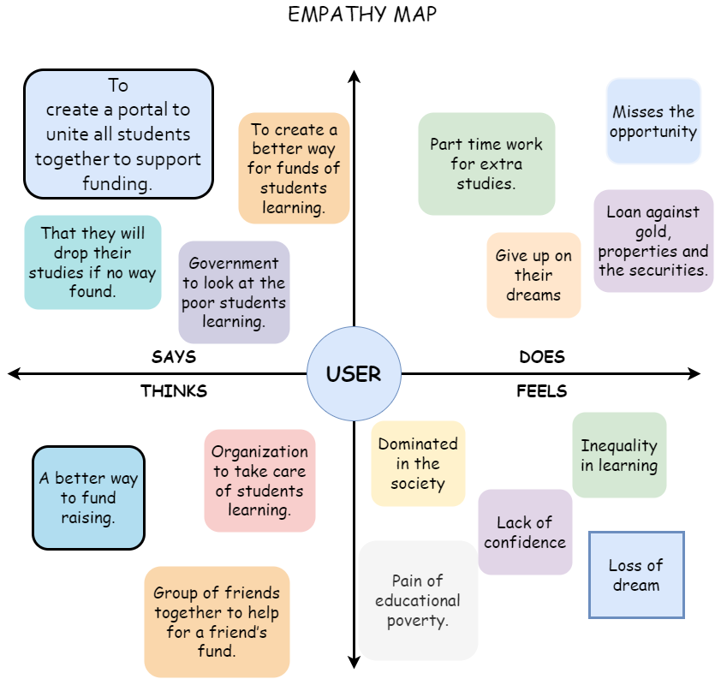

Figure 3.1 Empathy Map Crowdfunding.

**3.2 CUSTOMER JOURNEY MAP**

Customer journey mapping (known as user journey mapping) is the procedure of producing a customer journey map, a visual article of your customers’ interactions with your trademark. This practice helps businesses step into their customer’s shoes and view their business from the customer’s point of view. It authorize you to obtain insights into overall customer pain points and how to enhance those. Initially, all the feasible customer touchpoints are mapped out, for example, a web site, social channels, interactions with marketing and sales teams. User journeys are then created over these different touchpoints for each customer persona. For example, a millennial buyer persona may ordinarily become aware of a product on social, research it on the mobile edition of your site, and conclude make a buying on a desktop computer.

**Why is customer journey mapping important?**

Customer journey mapping is important, considering it is a strategic technique to better understanding customer expectations and is critical for optimizing the customer experience. Customer journey mapping is just as essential for smaller and medium-sized enterprises as it is for major companies. Customer expectations are varying for all businesses, regardless of size – customers demand an omnichannel procedure to customer service, marketing and sales.

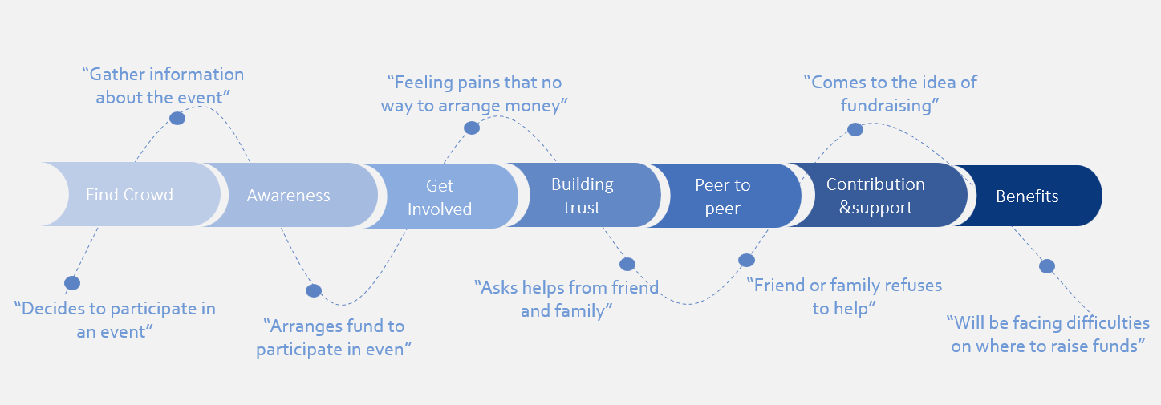

Figure 3.2 Customer Journey map Crowdfunding

**CHAPTER 4**

**PROBLEM DEFINITION**

Poverty impacts many people. But, perhaps, the effects of poverty are seen maximum in children. And, with a 1.21 billion population living below the poverty line in India, the children are sure to endure the reverberation of it. Not only does poverty affect a child’s development and educational consequence. Education begins at home. In fact, many studies indicate that being read to in the initial few years of a child’s life contributes to the development of phonemic and comprehension ability. Nevertheless, children from families living beneath the poverty line are less likely to be read to, extremely restricting the proper growth of their skills. Furthermore, parents who have not obtained a proper education tend to underestimate the importance of education and are hesitant to „waste‟ money on schools. And, even those children that do attend school have to face taunts and are frequently treated as outcastes as the present origination children do not accept anyone if they are not from their strata of the society.

India, which now has the world’s third-biggest economy in acquisition power parity, has been an urban-cantered, industrialized nation as long as its freedom in 1947. Over period of the past 25 years, India has been reported for its significant financial growth, which looks to proceed for the 2017 -2018 budgetary annual with an expected expansion rate of 7.2 percent. While India has retained much economic success, many collapses and failures still enervate the nation’s full ability.

For example, the impoverishment rate in India has been less intense in recent years, but there is still much room for advancement. In 2016, 270 million Indians were abiding on $1.90 or less daily, the World Bank’s definition of severe poverty. Of the people living in these terms, 80 percent lived in rural India, where the main source of income for people is casual labor. While the economy has roared over the past 25 years, most growth has been in downtown areas where large international corporations, such as IBM and Microsoft, base their program development head office. With this separate between urban and rural life, economical increase does not seem to remove the issues of intense indigence in the way a neoliberal economist could suggest. A study in 2002 found that these terms in India are partially due to educational poverty, definite as

the deprivation of basic education and scholarship. Only 6% of the income from poor family is invested into education and health, while the most is spent on other requirement such as food and fuel.

With the utmost poverty rate in India falling from 53.86 percentage in 1983 to 21.23 percent in 2011, the World Bank firmly considers that education is a powerful instrument for poverty reduction. While the reducing in the immoderate poverty rate in India over the past 20 years in India are not due exclusively to educational advancement, the investment in enhancing basic education has had a substantial impact on the poverty rate in India.

**CHAPTER 5**

**PATENT SURVEY**

**CHAPTER 6**

**PROPOSED METHODOLOGY**

The proposed system of crowdfunding for education consists of two major modules which leads to all sub modules of the system.

**6.1 USER ACTIVITES**

* Every fundraiser(user) must need to have an account to make a new fundraising request.

**6.1.1 USER FUNDRAISE ACTIVITES**

* A user can also avail for funds for his/her colleagues.
* Users are students who can make a new fundraise, edit and manage it.
* They can donate for any other fundraising made by other users.
* Users are able to vote for other fundraising requests which makes a fundraising to be featured which attracts more users.

**6.1.1 USER WALLET ACTIVITES**

* User can add money to the digital wallet inside the application and make a withdrawal request.
* User can view the transaction of his/her wallet.
* Any donation to a fundraise or amount received from other users are linked to the digital wallet module.

**6.1.3 USER SECURITY ACTIVITES**

* Able to review login activities done by user in last three devices, this ensures that their wallet is completely secure.
* User will be automatically logged out in another device, if made a login in in a different device.
* Users are able to change their password using their old password or using OTP method for case of forget password.

**6.2 ADMIN ACTIVITES**

* Admins are the next level of users who have more provisions than the users to make the application in the stable state

**6.2.1 USER FUNDRAISE ACTIVITES**

* Admins can make a fundraise request to freeze/hold of any suspicious activities.
* Admins are able to promote a fundraising request to the featured state.
* Admins are only able to approve/reject a newly raised fundraising request.
* Admins can view the transactions made on a fundraising request.

**6.2.2 ADMINS ACTIVITES ON USER ACCOUNTS**

* Admins can block a user for any suspicious activities.
* Admins are able to see a particular user’s wallet and it’s all transactions.
* Cash can be directly added to any user by admin.

**6.3 APPLICATION ARCHITECTURE**

An application architecture describes the patterns and techniques used to design and build an application. It contains information about the work flow of the application, database architecture and the design of the application.

**6.3.1 FRONTEND OF APPLICATION**

React is a popular, free and open-source front end JavaScript library for developing user interfaces based on UI components. It is maintained by Meta (Facebook) and a huge community of individual developers and companies uses react. React can be used as a very base in the development of single page, mobile, or server-rendered applications with frameworks like Next.js which is for entirely focused on full stack. Despite that, react is only concerned with state and hooks management and rendering that state to the DOM, so creating React applications usually requires the use of additional libraries for routing, as well as certain client-side functionality

Bootstrap is a free and popular open-source CSS framework directed at responsive, mobile-first front-end web development. It include HTML, CSS and JavaScript-based design templates for typography, forms, buttons, navigation, and one more interface components. Bootstrap is an HTML, CSS & JS Library which focusing on simplifying the development of informative web pages (as opposed to web apps). The primary purpose of increasing it to a web project is to implement Bootstrap's choices of color, size, font and layout to that project. As such, the primary part is whether the developers in charge identify those choices to their liking. Previously added to a project, Bootstrap provides fundamental style definitions for all HTML elements. The outcome is a uniform appearance for prose, tables and form elements cross web browsers. In extension, developers can hold advantage of CSS classes determined in Bootstrap to further modify the appearance of their contents. For sample, Bootstrap has provisioned for light- and dark-colored tables, page headings, additional prominent pull quotes, and text with a highlight.

**6.3.2 BACKEND OF APPLICATION**

Spring Boot is an one of the popular and open source, microservice-based Java web framework. The Spring Boot framework build a full production-ready environment that is entirely configurable using its pre-built code within its codebase. The microservice architecture provides developers with a totally enclosed application, including embedded application servers.

Spring Boot is an just extension of the already existent and expansive Spring frameworks, but it has several specific features that make the application simpler for working within the developer ecosystem. That extension includes initially-configurable web starter kits that help facilitate the responsibilities of an application server that are mandatory for other Spring projects.

PostgreSQL is a powerful, open-source object-relational database system with across 30 years of active development that has earned it a robust reputation for dependability, aspect robustness, and achievement.

There is a fortune of information to be build defining how to install and use PostgreSQL using the authorized documentation. The PostgreSQL communal provides various helpful places to make familiar with the technology, find how it works, and find career possibilities.

**6.3.3 DATABASE DESIGN**

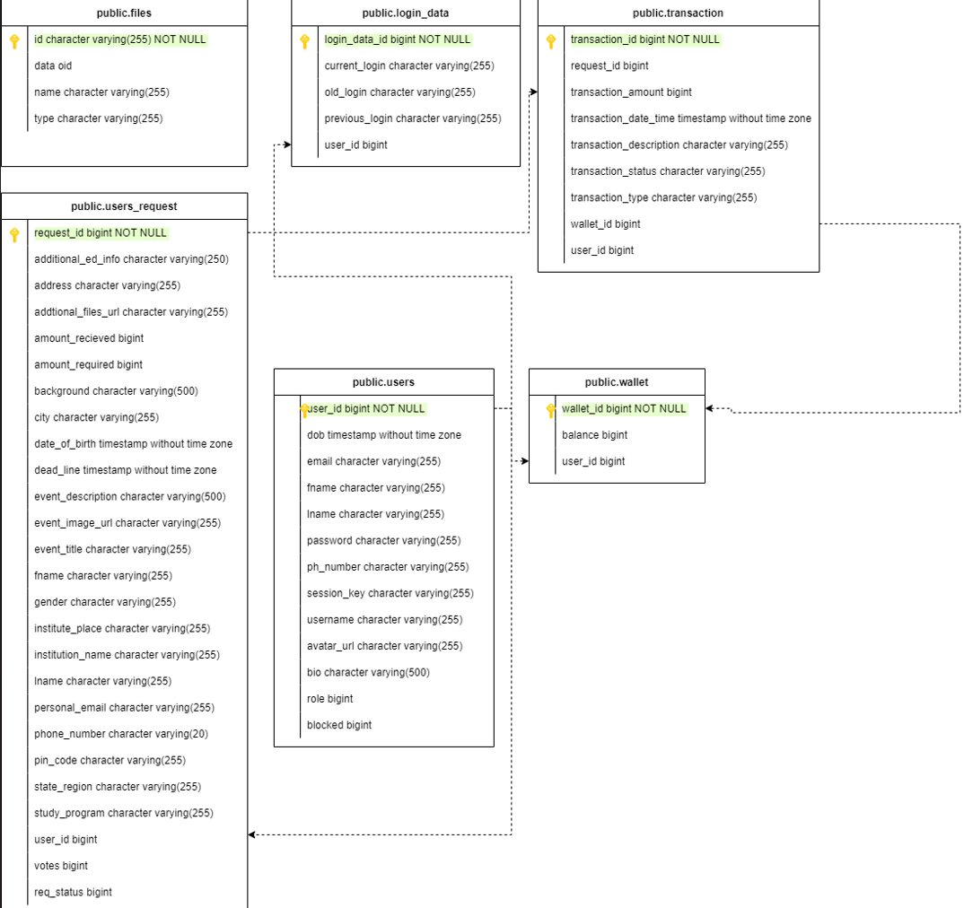

Figure 6.1 Database table architecture.

**6.3.4 APPLICATION WORKFLOW**

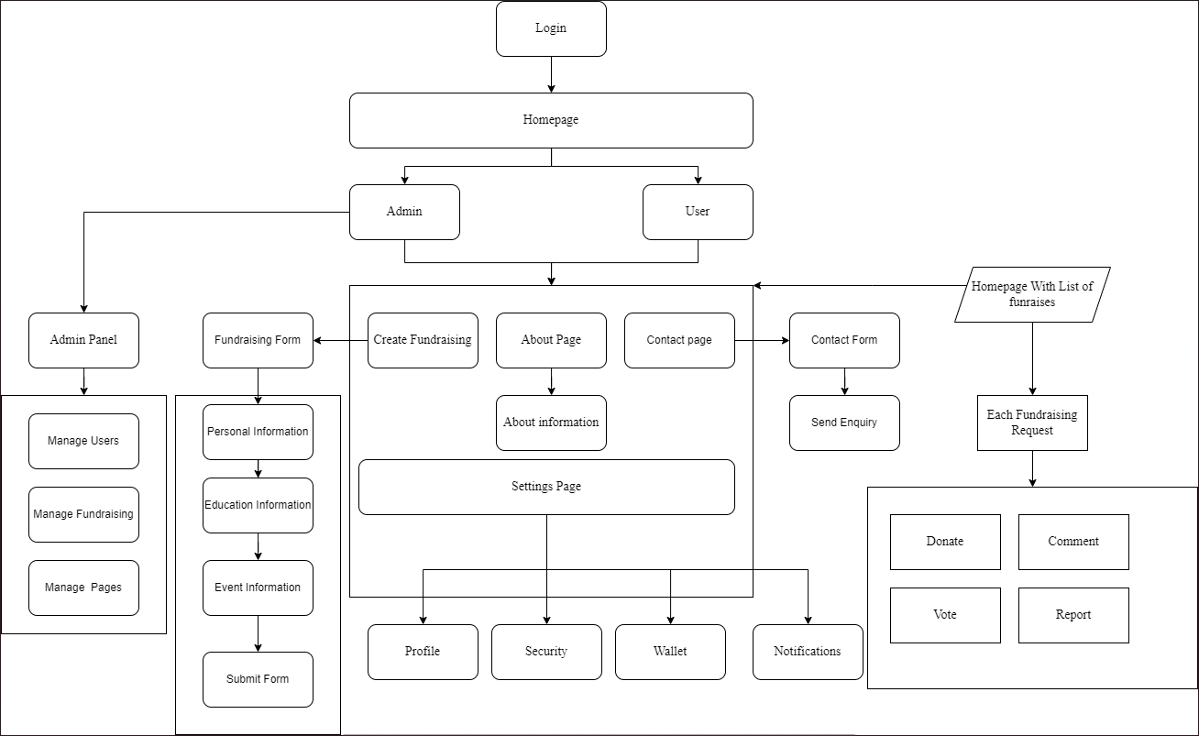

Figure 6.2 Application workflow design

**6.4 REQUIREMENTS**

A System Requirements Specification is a structured collection of information that embodies the requirements of a system. A business analyst, sometimes titled system analyst, is responsible for analyzing the business needs of their clients and stakeholders to help identify business problems and propose solutions

**6.4.1 CLIENT REQUIREMENTS**

* Windows 7, Windows 8, Windows 8.1, Windows 10 or later
* An Intel Pentium 4 processor or later that's SSE3 capable
* A browser to access the web.

**6.4.2 SERVER REQUIREMENTS**

* System Requirements. Spring Boot 2.0. RELEASE requires Java 8 or 9 and Spring Framework 5.0. RELEASE or above.
* Can run Eclipse on any normal low budget computer with a 64 bit operating system, so any machine that runs Windows 7/10, a recent version of MacOS, or a recent version of Linux will be just fine.

**CHAPTER 7**

**EXPERIMENTAL RESULTS**

**7.1 DEPLOYEMENT OF APPLICATION FOR LIVE USAGE**

The crowdfunding app was named as Fundsho crowdfunding and then later deployed for the usage of clients in the Vercel and Heroku.

**7.1.1 VERCEL EDGE MIDDLEWARE**

Vercel is an frameworks deployment site which takes care of building projects and making them live Here it manages all react publication through CDN at fundsho.karthifairhawn.in and the app was connected with git project to make new releases reach the customer as soon as possible.

**7.1.2 HEROKU CLOUD**

Heroku cloud is to manage PostgreSQL database that is managed in AWS servers and Spring boot deployment kit is available at Heroku server for use that manages all dependencies thus enhances the productivity of the development of the application.

**7.13 APP DEPLOYEMENT STATUS AND SCREENSHOTS**

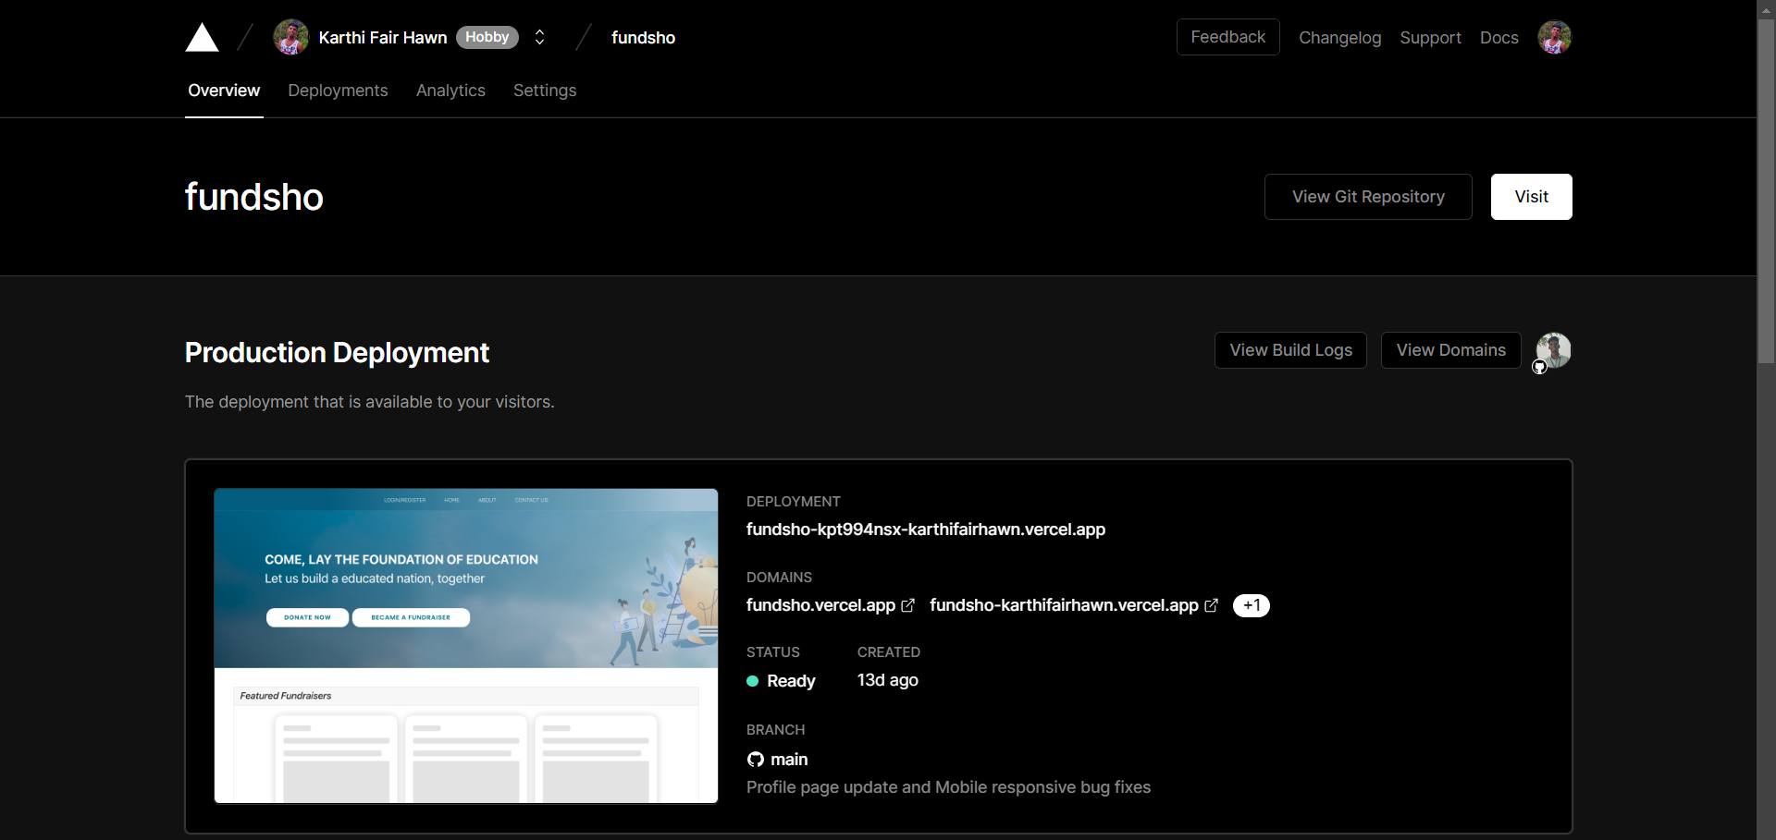

Figure 7.1 Deployment status in vercel.

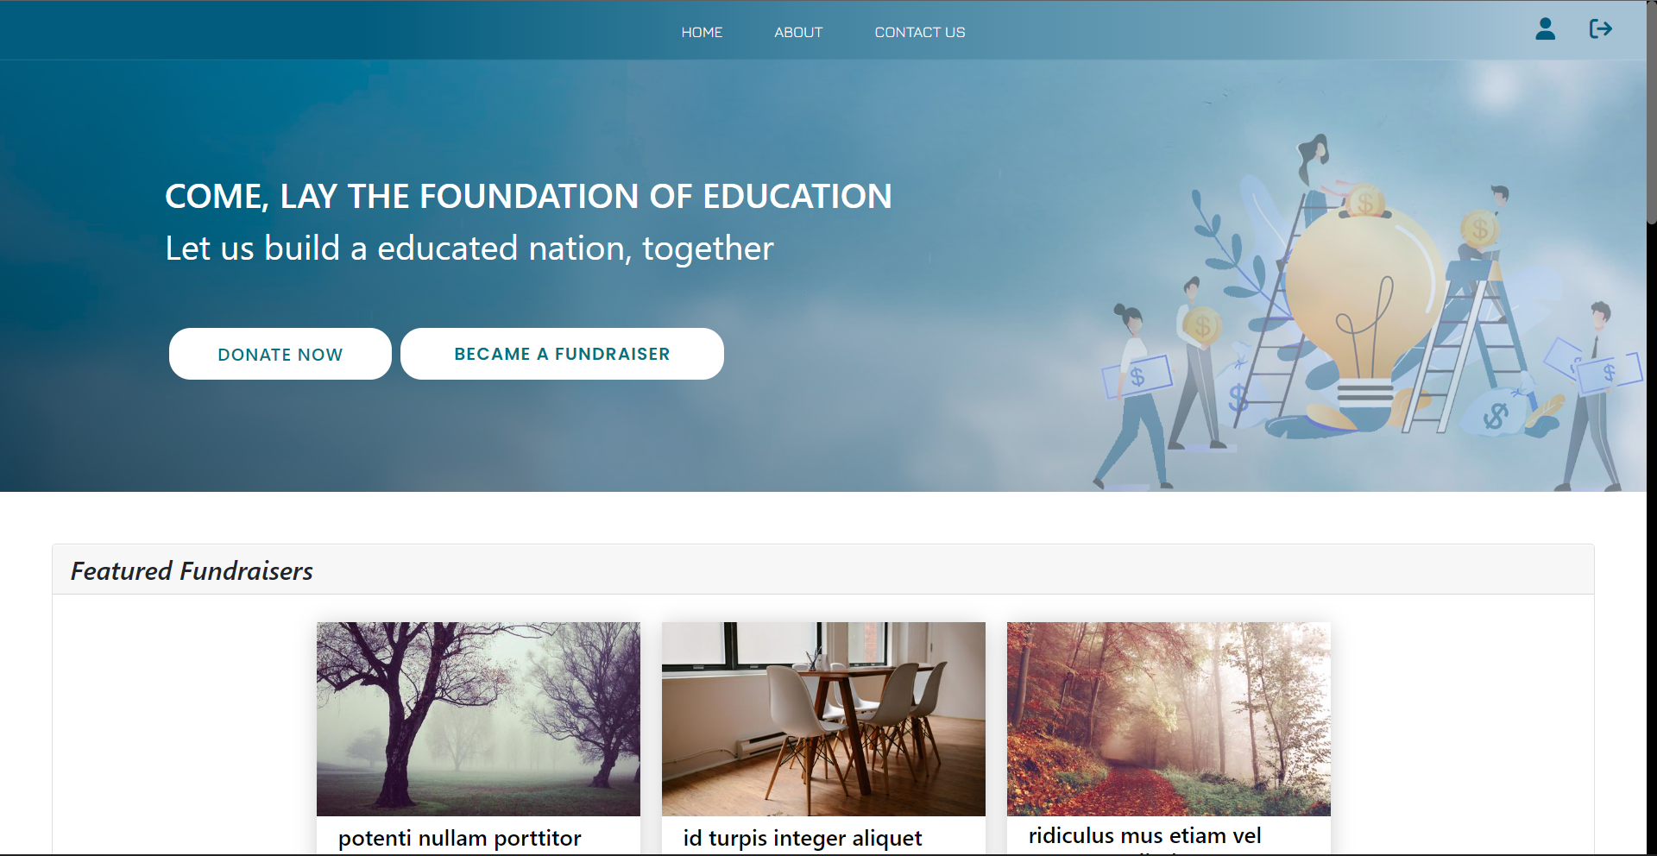

Figure 7.2: Homepage with cover image

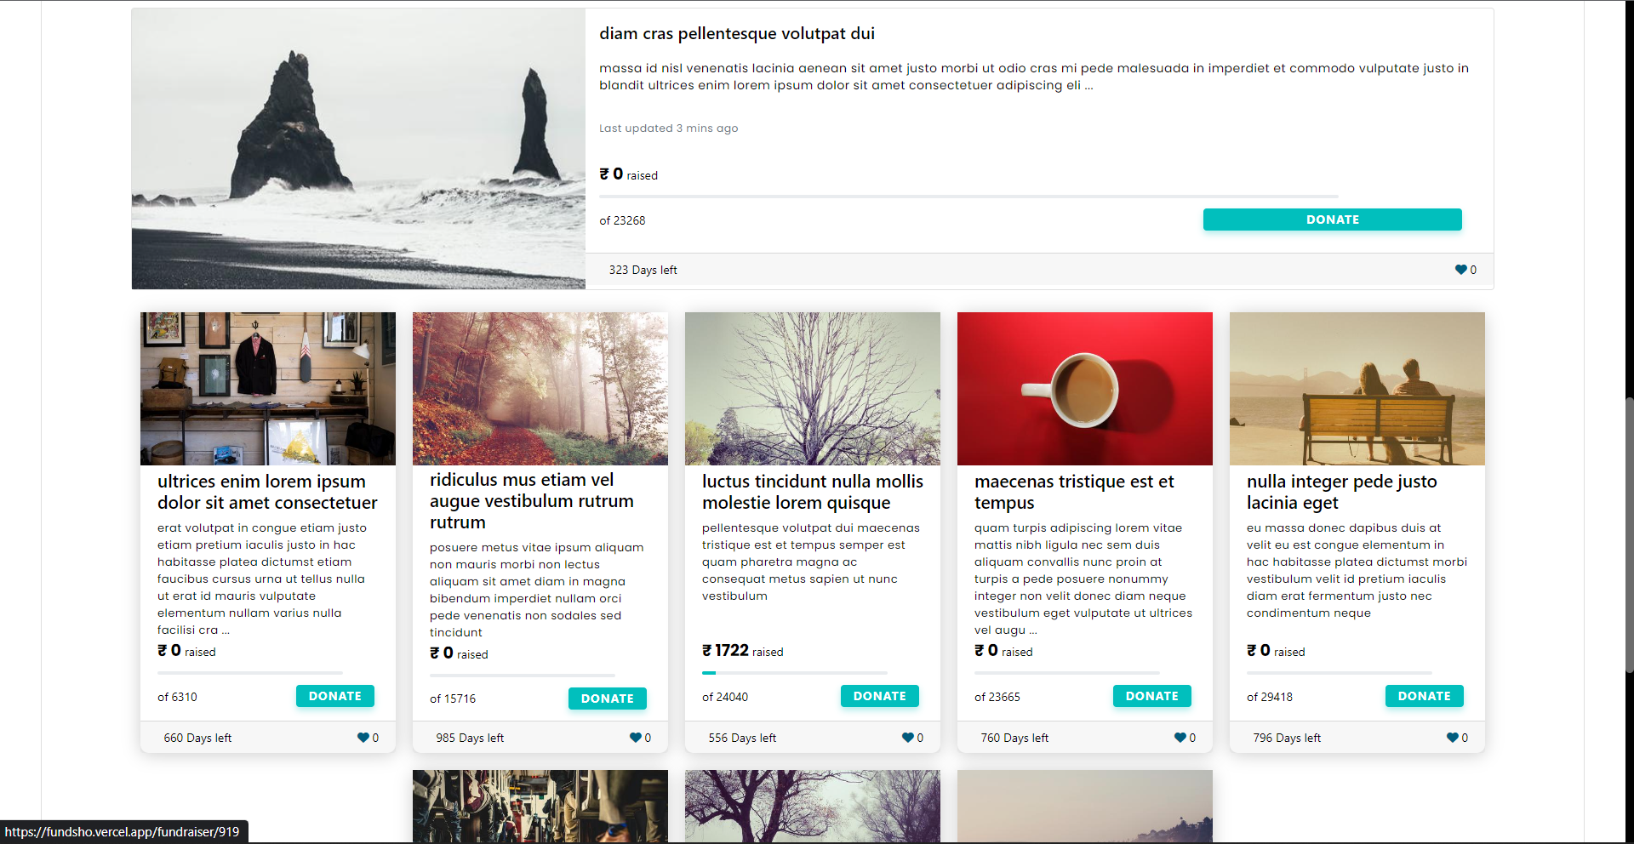

Figure 7.3: Listing all fundraisers in card with attracting title cards uploaded by users

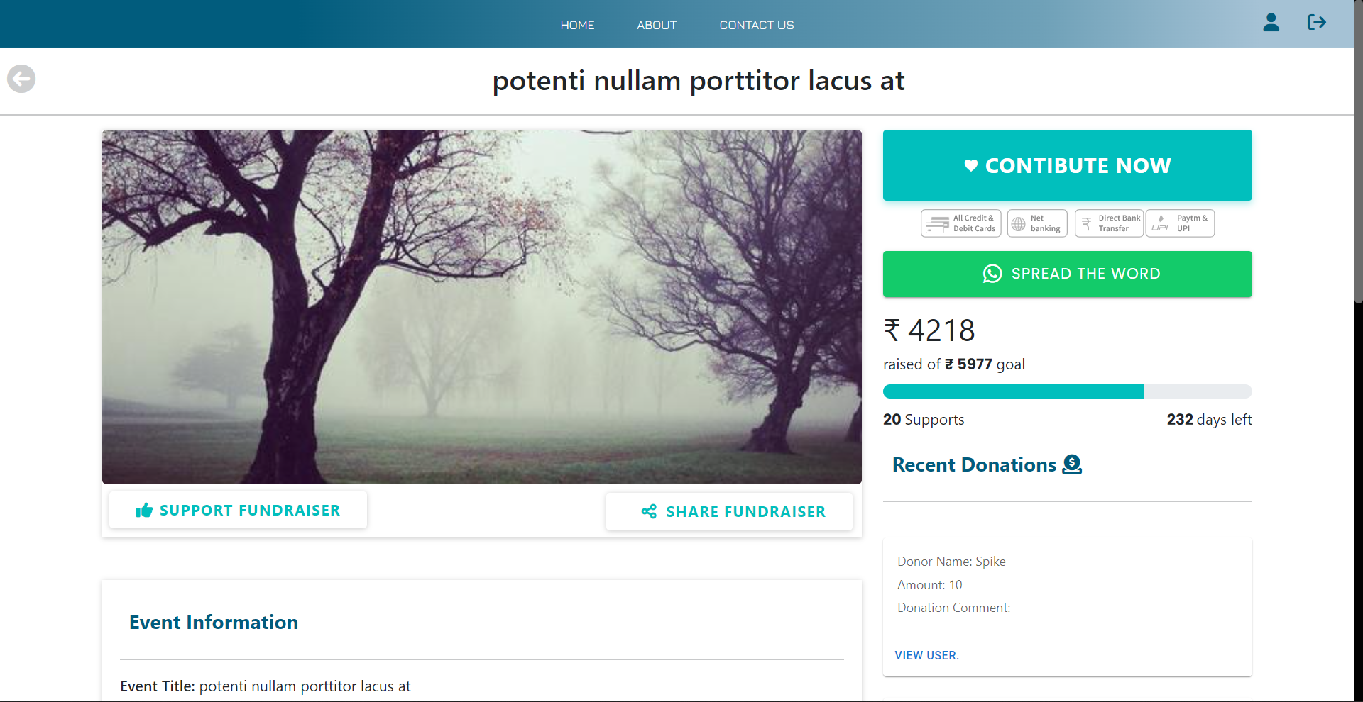

Figure 7.4: Page listing of fundraising request with donation and share options

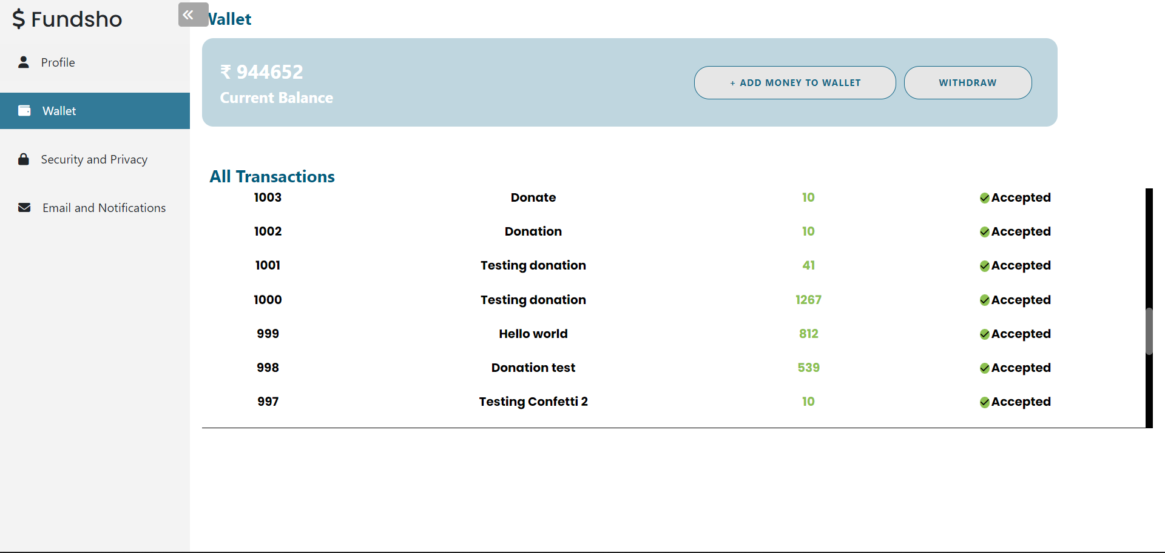

Figure 7.5: Wallet page with transaction table

**CHAPTER 8**

**CONCLUSION**

**REFERENCES**

1. Zhuoxin Li & Jason A. Duan [Dynamic Strategies for Successful Online Crowdfunding](https://ideas.repec.org/p/net/wpaper/1409.html)," [Working Papers](https://ideas.repec.org/s/net/wpaper.html) 14-09, NET Institute.- 2014
2. Claire Ingram, Robin Teigland and Emmanuelle Vaast Crowdfunding in Action: How Institutional Logics Encourage and Constrain Affordance Perception - 30 Nov 2017
3. Chen Zhou, Manpreet Gill, Qiang Liu - Empowering Education with Crowdfunding: The Role of Crowdfunded Resources and Crowd Screening November 2, 2021
4. Bagheri, Afsaneh, Chitsazan, Hasti, Ebrahimi, Ashkan (2019) Crowdfunding Motivations: A Focus on Donors’ Perspectives,” Technological Forecasting and Social Change, 146, 218–32.
5. Cachero, Paulina, Why Some School Districts Are Banning Teachers from Crowdfunding to Pay for Classroom Supplies – 2019
6. Dai, Hengchen, Zhang, Dennis J, “Prosocial Goal Pursuit in Crowdfunding: Evidence from Kickstarter,” Journal of Marketing Research, 56 (3), 498–517 – 2019
7. Gao, Qiang, Lin, Mingfeng, Wu, D.J, “Educational Crowdfunding and Student Performance: An Empirical Study,” Information Systems Research, 32 (1), 53–71. – 2021
8. Jacobson, Linda , “Requests on Education Crowdfunding Site ‘Exceptionally High,’” Education Dive -July 26 2018.
9. Kim, Chul, Kannan, P.K., Trusov, Michael, Ordanini, Andrea , “Modeling Dynamics in Crowdfunding,” Marketing Science, 39 (2), 339–65 – 2020
10. Mollick, Ethan , “The Dynamics of Crowdfunding: An Exploratory Study,” Journal of Business Venturing, 29 (1), 1–16 2014.
11. 48 Suffolk U. L. Rev. 131Crowdfunding & Investor Education: Empowering Investors to Mitigate Risk & Prevent Fraud -2015.